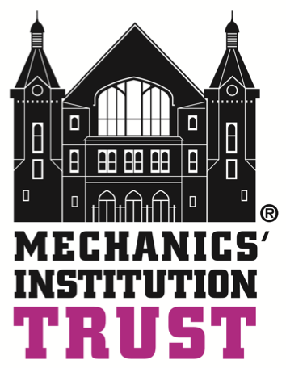

Central Community Centre and Health Hydro

Booking Form

Title | First Name |  | Surname
Organisation
Address
Postcode
Telephone
E-mail

Date(s) of proposed booking | Times of booking | Booking title
Which space(s) do you require?
Small Meeting Room
Main Hall
Large Meeting Room
Activity Room (Health Hydro)

If you would like the space set up please give details below (e.g. theatre style, boardroom etc)
Number of attendees:

Do you require any of the following (see price list):
Projector and screen
PA system
Flip chart stand
Flip chart paper
Flip chart pens
Tea and coffee
Tea, coffee and biscuits
Buffet lunch

Alcohol (a separate Temporary Event Notice may be required at an additional cost):
Available for sale | Yes | No
Available for consumption | Yes | No

Please select one of the following:
Private functions (such as birthday parties) | Local voluntary and community sector | Statutory Sector | National voluntary/charity sector | Commercial

Please let us know if you have any other requirements:

Please return all booking forms to one of the following:

The Mechanics’ Institution Trust
Head Office
Community Centre bookings
Health Hydro
Milton Road
Swindon
SN1 5JA

centralcommunitycentre@mechanics-trust.org.uk

